Date:

Name
Address
City, State
Country

Re: Judging Guidelines
SBTCA Show Date and Location

Dear (Judges Name):

Congratulations on being selected to judge the Staffordshire Bull Terrier Club of America (Show Title). The following is some information we hope will assist you in becoming familiar with the way classes are judged and awards presented in the United States. If you have any questions before judging commences, there will be a show committee representative and an AKC Field Representative available to respond. Once judging begins your ring stewards will also be able to help you with judging procedures.

JUDGING ALL CLASSES: AKC rules require that the whole class come into the ring at one time so that you can mark your book as to a dog’s presence or absence. Customarily, the entire class is gaited once around the ring when you have completed marking your book. After this initial round, if the class is very large, you may wish to divide it into smaller groups. This approach is especially useful for judging Best of Breed but can be used for any large class. It’s a common practice and considered courteous to both the dogs and exhibitors.

One way of managing the Best of Breed class is to ask all the Champion Bitch’s (referred to as “Specials”), Winners Dog and Winners Bitch and Best Veteran Dog and Bitch to leave the ring, while having all the Champion Dog’s (Specials) remain. You may then break the Dog Specials into smaller groups (say 12-15) to be judged. The ring steward will be responsible for keeping track of each group and getting dogs into the ring in the correct order. You can do the same with the Bitch Specials.

As you judge the Specials (or any large class), it may be useful to mark down on paper the armband numbers of dogs you would like to see return for additional judging. The dogs which are no longer needed for further judging should be excused. The Specials which you wish to have recalled are brought back into the ring together with the Winners Dog and Bitch and Veteran Dog and Bitch. Any of these exhibits is eligible for Best of Breed and Best of Opposite Sex.

Judge (Name)
Date

CLASS JUDGING (Dogs without an AKC Championship Title)

6-9 months Puppy Dogs 6-9 months Puppy Bitches
9-12 months Puppy Dogs 9-12 months Puppy Bitches
12-18 months Dogs 12-18 months Bitches
Novice Dogs Novice Bitches
American Bred Dogs American Bred Bitches
Amateur Owner Handler Dogs Amateur Owner Handler Bitches
Bred-by-Exhibitor Dogs Bred-by-Exhibitor Bitches
Open Dogs Open Bitches
WINNERS DOG WINNERS BITCH
RESERVE WINNERS DOG RESERVE WINNERS BITCH

All Dog classes will be judged first in the above order. After awards are made in the Open class the first-place dog from each class comes back into the ring to compete for WINNERS (points awarded towards their Champion title). All the first-place dogs are equally eligible for the Winners award. You may examine each exhibit again and/or ask the handlers to gait them, whatever is necessary for you to make a decision. Once you have decided on the Winners dog, AKC rules require that the dog which was second in the class from which the Winners dog came must be called back into the ring and included in the judging of RESERVE WINNERS dog. The above procedure is repeated with the Bitch classes.

VETERAN DOG/BITCH classes:
The Veteran classes are also divided by sex as well as age. Veteran Dog class is judged first, followed by Veteran Bitch. Veteran classes are for dogs/bitches seven (7) years to ten (10) years and ten (10) and older. The first-place winners of each of these classes comes back into the ring to compete for Best Veteran Dog and Best Veteran Bitch and the winners are eligible for Best of Breed. Please note: If this is a Standalone Specialty Show this is the only class that allows for a dog to be spayed or neutered.

BEST of BREED Class (Dogs with AKC Championship Titles):
Dogs and bitches that have completed their AKC Championship title (referred to as “Specials”) make up the bulk of the entries in the Best of Breed class. In addition, the Winners Dog, Winners Bitch, first place winners from the Veteran Dog and Bitch classes return to the ring to compete for Best of Breed. ALL dogs in the ring are equally eligible for the Best of Breed award. You make three awards from this class: Best of Breed, Best of Opposite Sex to Best of Breed, and Best of Winners (Points awarded towards their Champion title). Best of Opposite Sex is chosen from exhibits in the ring which are opposite in sex to Best of Breed. Best of Winners is chosen between the Winners Dog and Winners Bitch. If the Winners Dog or Winners Bitch is chosen Best of Breed, it is automatically Best of Winners. In addition, you will award Select Dog, Select Bitch, Best Owner Handled as well as Judges Awards of Merit (usually the number given out is based upon 10% of entire entry).

Judge (Name)
Date

SELECT DOG/BITCH:
After the Best of Breed and Best Opposite Sex are awarded the remaining Champions “Specials” are eligible to be awarded Select Dog and Select Bitch. You shall only select one Dog and one Bitch to present the Select Award. Please Note: This award provides points towards the dog/bitches “Grand Championship Title”.

BEST OWNER HANDLED: The Ring Steward or AKC Field Rep will help you with this. There is a chart which can be used to help which can be found at the end of this file. All eligible Owner Handled participants will remain in your ring after you make your other awards. They must have marked the OH box when they made their entry. The Stewards catalog book will have an asterisk by their names. If your breed winner is also OH eligible then they are automatically your OH winner. Refer to the chart for further details and ask your Steward or the Field Rep.

JUDGES AWARD OF MERIT: Traditionally at SBTCA Specialty shows, these awards may (but are not required to) be given to as many as 10% of the dogs entered in the Best of Breed class. They should not be awarded to the Best of Breed or Best of Opposite Sex because those dogs have already received top honors. Instead, Judges Awards of Merit should be chosen from the remaining Specials, as well as the Winners Dog/Bitch and Veteran Dog/Bitch.

NON-REGULAR CLASSES: See the following

STUD DOG and BROOD BITCH classes: These classes are judged on the merits of the GET ONLY. The conformation of the Stud Dog or Brood Bitch is not considered.

BEST BRED-BY-EXHIBITOR: The winners of both the Bred-by-Exhibitor classes (dog and bitch) return to the ring, one to be chosen Best.

BEST VETERAN: The winners of the Veteran classes (dog and bitch) return to the ring, one to be chosen Best.

BEST BRACE: Handlers in this class will present two Staffords at once. They gait and stand for exam exactly like the other classes. You make your selections based upon the breed standard like always but in addition you also look for consistency and similarities in type, movement, structure, presentation and temperament.

We look forward to seeing you at the Specialty and hope that your assignment is enjoyable. If there’s anything more we can do to help, please let us know.

Sincerely,

(Show, Name, Club Chair or Liaison)

HELPFUL INFORMATION:

Your SBTCA Judges Liaison for this show is:
Name: _____________
Phone #: _____________
Email address: _____________

Your Schedule for this show is:

Ring Time: _____________
Ring #: ____________
Counts: ____________

Your hotel/AirBNB location is:

The address for the showgrounds is:

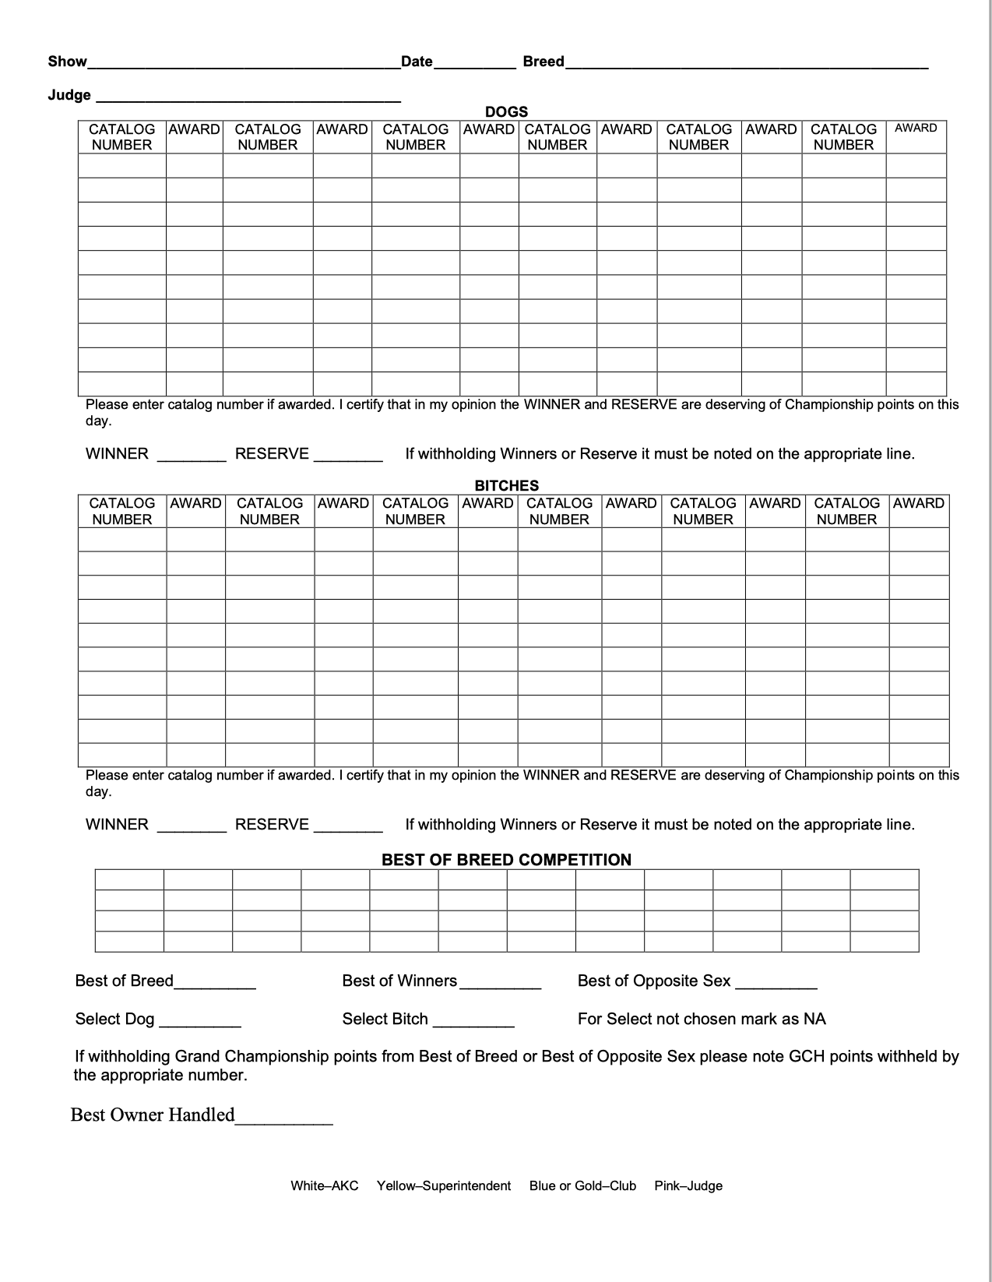

Ribbons:

Each dog that receives an award is given a ribbon by the judge. The color of the ribbon indicates the type of award the dog has won.

Blue — awarded for first place in any regular class. Also awarded to the winner of each group competition, usually in the form of a “rosette”.

Red — awarded for second place in each class. Also awarded for second place in each group competition, usually in the form of a “rosette”.

Yellow — awarded for third place in each class. Also awarded for third place in each group competition, usually in the form of a “rosette”.

White — awarded for fourth place in each class. Also awarded for fourth in each group competition, usually in the form of a “rosette”.

Purple — awarded to the winners of the Winners Dog and Winners Bitch classes. Since these are the classes in which championship points are earned, these ribbons are highly coveted.

Purple and White — awarded to the Reserve Winners, that is, the runners-up to the winner of the Winners Dog and Winners Bitch classes.

Blue and White — awarded to the dog that wins Best of Winners; that is, the better of the Winners Dog and Winners Bitch winners.

Purple and Gold — awarded to the dog judged “Best of Breed” in each breed competition. This is highly coveted because it allows advancement to the Group competition.

Red and White — awarded to the Best of Opposite Sex. This means the best dog of the breed that is the opposite sex of the Best of Breed winner.

Light Blue and White — two of these awarded to the Select Dog and Select Bitch in the Best of Breed competition awarded points towards earning a Grand Championship Title.

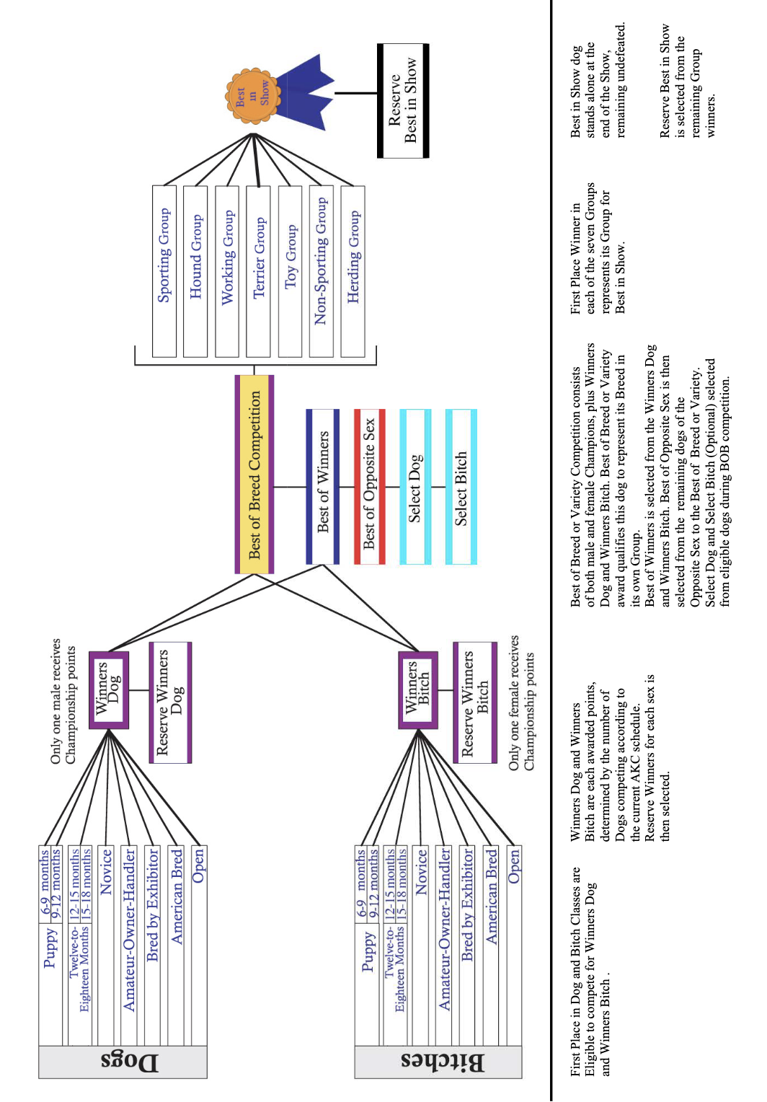

OWNER HANDLER ELIGIBILITY AND JUDGING INFORMATION:

