Staffordshire Bull Terrier Club of America 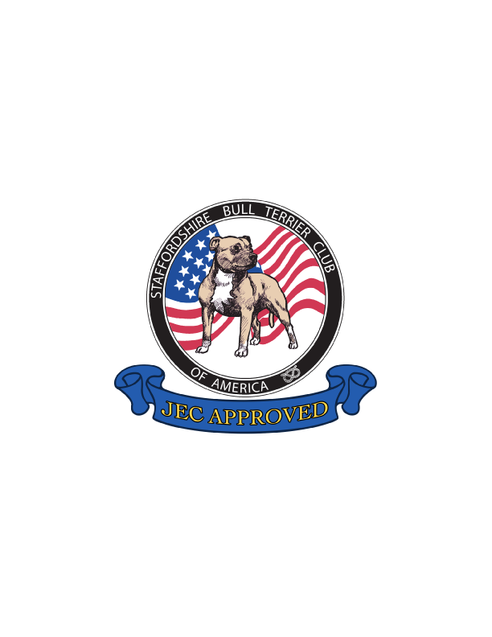
Judges Education Committee

STAFFORDSHIRE BULL TERRIER CLUB of AMERICA JUDGES’ EDUCATION COMMITTEE APPLICATION

ROLE:
The role of the Judges Education Committee is to participate in the protection and preservation of the Staffordshire Bull Terrier through breed education.

MISSION STATEMENT
The purpose of the SBTCA JEC is to put forth enough accurate and consistent information based upon the AKC written BREED STANDARD to all judges which assists in understanding all nuances of the Staffordshire Bull Terrier which then in turn makes up Stafford BREED TYPE. This breed specific information is what specifically differentiates one breed from another. With this information, when in the ring the judge will take everything into consideration and place accordingly.

Code of Ethics and Conduct:
All JEC Committee members are representative of The Staffordshire Bull Terrier Club of America and our Breed. All members of this committee will:
· Respect the tradition, history and integrity of the Staffordshire Bull Terrier
· Be familiar with our Breed Standard as approved by the American Kennel Club and the Illustrated Standard as approved by the SBTCA board.
· Always have the best interests of our committee in mind
· Committee members will be honest, courteous and respectful to one another
· Will not take personal advantage of their position as a JEC Committee member.
· Will never promote their own dogs or dogs of their breeding when acting in the capacity of a ringside mentor, seminar presenter / participant, author of public articles or when otherwise providing information (even casually) to any judge or aspiring judge
· Will accept constructive criticism
· Display good sportsmanship, civility, and honesty

The following are basic criteria for a SBTCA member to become a Judges’ Education Committee member:

Name: ________________________________________________________
Address: _________________________________________________
Phone Numbers: _________________________________________________
E mail Address: __________________________________________________
· I am a member of the SBTCA in good standing: ___________
· I am currently in good standing with the AKC: ____________
· I am a member of another SBT Club in addition to SBTCA: _________

1. I am a licensed AKC Staffordshire Bull Terrier breeder judge with approved status.
YES ___________ NO ____________
If YES, please provide AKC Judges license number and breeds licensed for and proceed to QUESTION #6.
AKC Judges License No.#: _____________ Breeds Licensed to judge:
_______________________________________________________________________
_______________________________________________________________________
_______________________________________________________________________

2. I have 12 or more years’ experience breeding or exhibiting Staffordshire Bull Terriers in conformation. YES ___________ NO ____________
3. I have planned, bred, whelped and raised in my home 4 or more litters of Staffordshire Bull Terriers YES ___________ NO ____________
Please list dam's registered name and whelping dates of at least 4 litters:
________________________________________________________________________
________________________________________________________________________
________________________________________________________________________
________________________________________________________________________

4. I have planned, bred and whelped 5 or more Staffordshire Bull Terriers AKC Champions. Please list the champions’ names and AKC numbers.
________________________________________________________________________
________________________________________________________________________
________________________________________________________________________
________________________________________________________________________
________________________________________________________________________

5. JEC Mentor Applicants must complete 2 seminars. Staffordshire Bull Terrier, and one on another breed and must successfully pass the AKC online Canine Anatomy course and exam of each. Attended seminars must also include a HANDS ON portion - https://www.caninecollege.akc.org/user_catalog_class/show/858395
Please list 2 seminars and attach copies of proof of completion:
________________________________________________________________________
________________________________________________________________________

6. JEC members are expected to participate in maintaining and updating the documentation used by the committee, be available to present seminars when possible, assist with writing articles, and attend monthly meetings.
AGREE _________ DISAGREE _________

7. Judges wanting to join JEC are strongly encouraged to first become Club Approved ringside Mentors. JEC members who are NOT judges must first undergo and pass the training steps involved to become a Club Approved Ringside Mentor. Are you a Club Approved Ringside Mentor?
YES ___________ NO ____________
If you answered YES, what year did you get approved? _______________________

8. In the space below please offer suggestions for improvement, new ideas and please point out any issues that you see with the current Illustrated Standard or any of the other content on the JEC page with ideas for improvement:
https://sbtca.com/education/judges-education-committee/
________________________________________________________________________
________________________________________________________________________
________________________________________________________________________
________________________________________________________________________
________________________________________________________________________
________________________________________________________________________

9. Please provide any other information that you would like the committee to consider for your application.
________________________________________________________________________
________________________________________________________________________
________________________________________________________________________
________________________________________________________________________
________________________________________________________________________
________________________________________________________________________

Please return the completed application with proof of completed seminars and certificate of successfully passing the AKC online Canine Anatomy course and exam to: judgesed@sbtca.com
Adopted by JEC – January 2026

