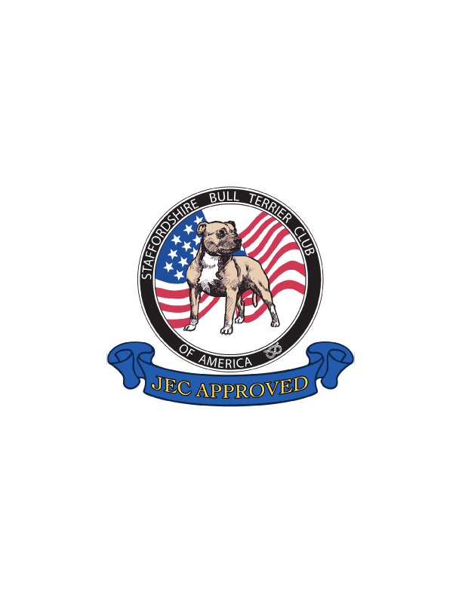
Staffordshire Bull Terrier Club of America
Judge Education Committee

Club Approved Ringside Mentor Application
The SBTCA Approved Ringside Mentor serves as a representative of the Judge Education Committee and as a guardian of the Staffordshire Bull Terrier. Approval is contingent upon completion of all requirements outlined below and successful completion of the provisional mentoring phase.

Section I – Applicant Information

Name: ________________________________________________
Address: ______________________________________________
Phone: ________________________________________________
Email: ________________________________________________
I am a member of the SBTCA in good standing: YES ____ NO ____
I am currently in good standing with the AKC: YES ____ NO ____

Section II – Experience & Qualifications

1. I have 12 or more years’ experience breeding and/or exhibiting Staffordshire Bull Terriers in conformation: YES ____ NO ____
2. I have directly participated in planning, whelping, and raising litters under my supervision.
Please list litters (dam’s registered name and whelping date):
________________________________________________________________
________________________________________________________________
________________________________________________________________
________________________________________________________________

3. I have personally whelped and raised 4 or more Staffordshire Bull Terrier AKC Champions.
Please list champions’ names and AKC numbers:
________________________________________________________________
________________________________________________________________
________________________________________________________________
________________________________________________________________

Section III – Required Education & Acknowledgments

The following items must be completed and submitted with this application:
☐ Signed acknowledgment of the Ringside Mentoring Ethics & Guidelines.
☐ Signed acknowledgment of the SBTCA JEC Mentor Eligibility Standards.
☐ Successful completion of the SBTCA JEC Mentoring Ethics & Guidelines Examination.
https://form.jotform.com/10040924123
☐ Proof of completion of the AKC ABC’s of Canine Anatomy course.
☐ Proof of attendance at an SBTCA Judges Education Seminar.

Section IV – Mentoring Philosophy

In the space below, briefly describe key breed priorities that should be emphasized when mentoring:
________________________________________________________________________________
________________________________________________________________________________
________________________________________________________________________________
________________________________________________________________________________
________________________________________________________________________________
________________________________________________________________________________

Section V – Provisional Approval Process

Upon review and determination that eligibility requirements are satisfied, applicants will enter a provisional phase.
• Sit ringside with an approved SBTCA mentor to review established mentoring procedures.
• Conduct a mentoring session while being observed by an approved mentor to ensure alignment with SBTCA educational standards.
Following successful completion of the provisional phase, the Judge Education Committee will conduct a formal vote for full mentor approval.

Applicant Certification
I certify that all information provided in this application is accurate and complete. I understand that any material misrepresentation or omission may result in denial or revocation of mentor approval.

Typed Name:__________________________________________________________

Signature: __________________________________________ Date: ____________

